1. **Testing Report:**

8.1. Unit testing report:

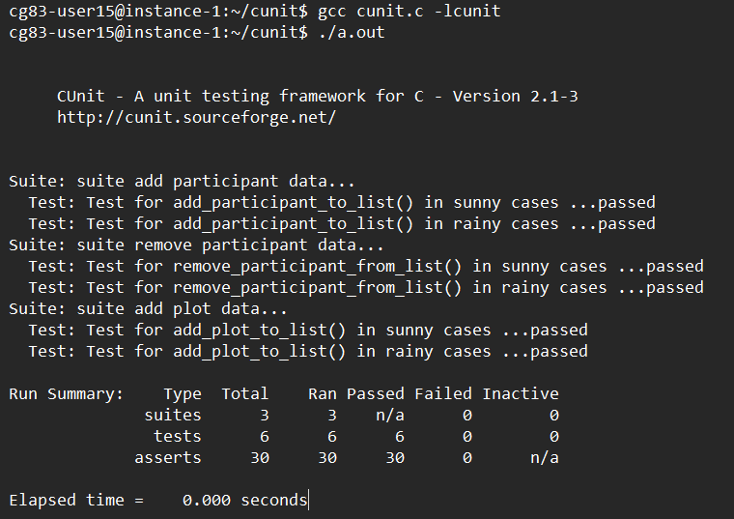

8.2. Integration testing report:

Case-1: Grab token

Case 2: Cancel token

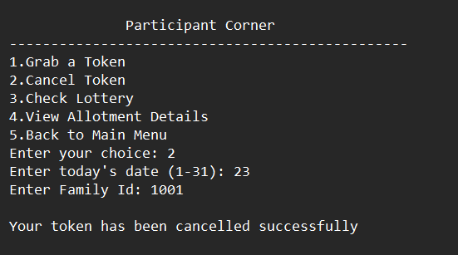

Case 3: View allotment details

Case 4: Edit plot details

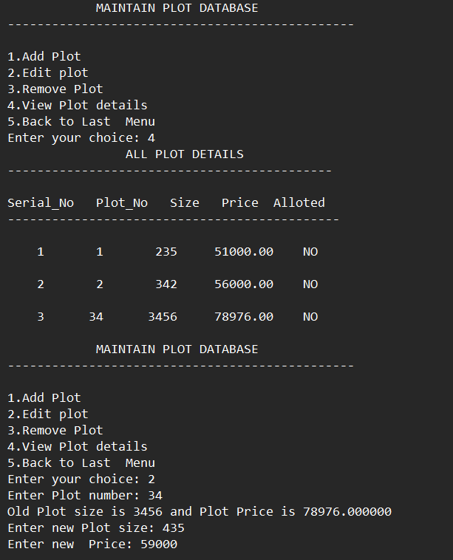

Case 5: Edit participant

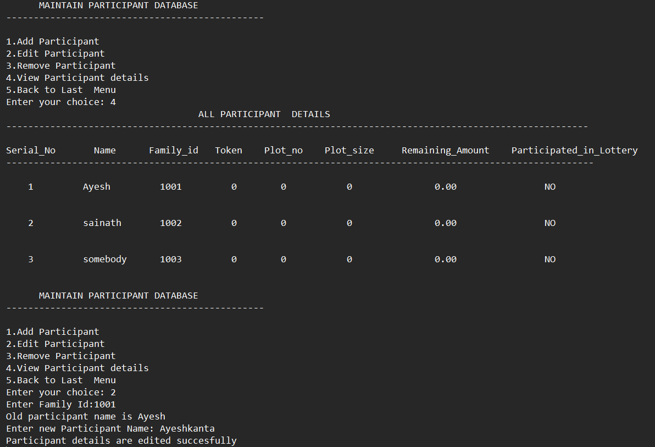

Case 6: Generate winning lottery

Case 7:Lottery confirmation

